Asymmetric DCC correlation: AUDUSD and EURGBP
Method 10 / GARCH(1,1) + Cappiello-Engle-Sheppard ADCC / Alpari D1 full available history

Study setup
Logical pair: AUDUSD , EURGBP
Broker symbols: AUDUSD_i , EURGBP_i
Snapshot: 2026-11-03_majors_alpari_D1
Timeframe: D1
Matched return window: 1999-01-06 to 2026-11-02 (UTC bar dates)
Matched return count n: 7198
Dropped unfinished last bar dated 2026-11-03 UTC after a tick-volume check against the prior complete day.
AUDUSD GARCH(1,1): mu=0.000025, omega=0.005413, alpha=0.052235, beta=0.937157
EURGBP GARCH(1,1): mu=-0.000021, omega=0.000660, alpha=0.046573, beta=0.951751
ADCC: a=0.012170, b=0.984730, g=0.000000, a+b+g/2=0.996900
Nested DCC (g=0): a=0.012170, b=0.984730
Negative shock: n = min(z, 0) in broker quote direction (not inverted)
Burn-in ignored in path summaries and chart: first 60 updates
Complete matched rows (Excel): AUDUSD-EURGBP_ADCC_D1.xlsx
Complete matched rows (HTML table): AUDUSD-EURGBP_ADCC_D1_data.html

Method carried forward
Asymmetric DCC extends Engle DCC with an extra term on joint negative standardised shocks. Each matched daily log return of close, ln(close_t / close_t-1), is first filtered by a constant-mean GARCH(1,1). Then z = residual / sigma and n = min(z, 0). The Cappiello-Engle-Sheppard recursion uses A = (1-a-b) Q_bar - g N_bar with N_bar = mean(n n'). Quotes are not inverted, so a negative shock is a negative log return in the broker quote. Nested symmetric DCC (g = 0) is fit on the same z path for comparison. Constraints: a,b,g >= 0 and a + b + g/2 < 1. Path summaries ignore the first 60 updates. The headline is latest ADCC rho. Pearson r is a side check only. This is not a cause, lead, or trading signal.

Results
Latest ADCC rho: -0.064510
Latest nested DCC rho: -0.064511
Post-burn-in ADCC path (n=7138): mean=0.039847, median=0.035893, min=-0.354799, max=0.474148, std=0.160489
Share of post-burn-in days with |rho| >= 0.4: 1.18%; |rho| >= 0.7: 0.00%
Same-sample Pearson r: 0.038173
ADCC minus r: -0.102684
ADCC minus nested DCC: 0.000000

Conclusion
Over 7198 matched daily log-return rows for AUDUSD and EURGBP (broker quote directions unchanged), latest ADCC rho is -0.0645 (negative, weak conditional linear link in this sample) with fitted a=0.0122, b=0.9847, g=0.0000. Nested symmetric DCC latest rho is -0.0645 (ADCC minus DCC = 0.0000). After a 60-day burn-in, path mean is 0.0398 and std is 0.1605. Same-sample Pearson r is 0.0382 (ADCC minus r = -0.1027). This does not establish cause, lead-lag, or a lasting trading rule.

Charts
Daily closes

Daily log returns
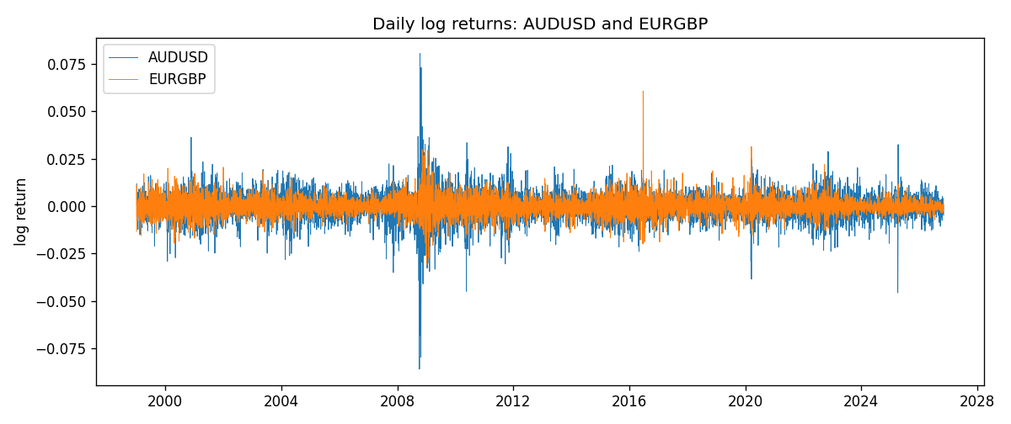
ADCC rho path with nested DCC and Pearson r
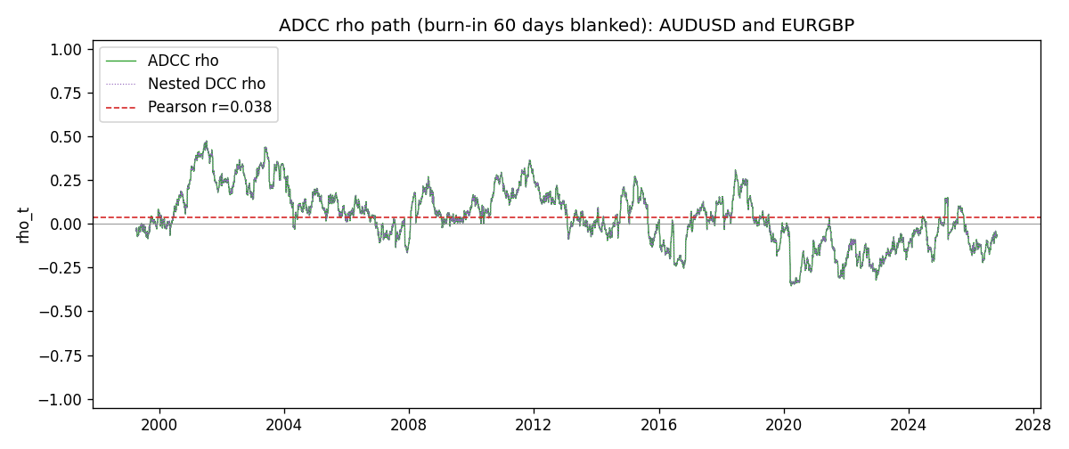

Data report
Every matched row that entered the ADCC recursion is stored in the sibling Excel workbook named AUDUSD-EURGBP_ADCC_D1.xlsx. Embedding all rows as a Word table is impractical at this length; the Word file holds the column list, column summaries, and the first and last 15 matched rows.
Columns: time, AUDUSD_open, EURGBP_open, AUDUSD_high, EURGBP_high, AUDUSD_low, EURGBP_low, AUDUSD_close, EURGBP_close, AUDUSD_tick_volume, EURGBP_tick_volume, AUDUSD_spread, EURGBP_spread, AUDUSD_real_volume, EURGBP_real_volume, AUDUSD_log_return, EURGBP_log_return, AUDUSD_sigma, EURGBP_sigma, AUDUSD_z, EURGBP_z, AUDUSD_n, EURGBP_n, q11, q22, q12, rho_adcc, rho_dcc
Column summaries (matched calculation rows)
column | count | mean | std | min | 25% | 50% | 75% | max
AUDUSD_open | 7198 | 0.75202191 | 0.13526259 | 0.4785 | 0.6611175 | 0.731685 | 0.8091425 | 1.10284
EURGBP_open | 7198 | 0.78667202 | 0.09675257 | 0.5734 | 0.687325 | 0.83369 | 0.8651775 | 0.9769
AUDUSD_high | 7198 | 0.7560731 | 0.13582215 | 0.4878 | 0.6648025 | 0.7351 | 0.8153975 | 1.10795
EURGBP_high | 7198 | 0.7897492 | 0.09712763 | 0.5789 | 0.6894 | 0.836595 | 0.86804 | 0.9799
AUDUSD_low | 7198 | 0.74796393 | 0.1345766 | 0.4775 | 0.6578225 | 0.727775 | 0.804275 | 1.0975
EURGBP_low | 7198 | 0.7839722 | 0.09657024 | 0.5682 | 0.6853 | 0.831475 | 0.8627775 | 0.9661
AUDUSD_close | 7198 | 0.75206897 | 0.13524509 | 0.4786 | 0.661255 | 0.7318 | 0.8092725 | 1.10169
EURGBP_close | 7198 | 0.78671595 | 0.09675201 | 0.5735 | 0.687525 | 0.83375 | 0.865285 | 0.977
AUDUSD_tick_volume | 7198 | 77378.184 | 138156.24 | 109 | 5445.75 | 43349.5 | 71356.75 | 1234623
EURGBP_tick_volume | 7198 | 86961.088 | 145396.59 | 332 | 6520.25 | 44270 | 81329 | 1424684
AUDUSD_spread | 7198 | 30.809114 | 16.88495 | 0 | 13 | 30 | 50 | 50
EURGBP_spread | 7198 | 21.389692 | 19.14164 | 0 | 4 | 13 | 50 | 50
AUDUSD_real_volume | 7198 | 5.2442754e+09 | 1.2540657e+11 | 0 | 0 | 0 | 0 | 3.811512e+12
EURGBP_real_volume | 7198 | 2.7809077e+10 | 1.3507993e+11 | 0 | 0 | 0 | 0 | 3.5726265e+12
AUDUSD_log_return | 7198 | 2.054e-05 | 0.00754782 | -0.08602525 | -0.00386556 | 0.00027727 | 0.00415374 | 0.0806166
EURGBP_log_return | 7198 | 2.199e-05 | 0.00487197 | -0.03067367 | -0.00262256 | -0.00010006 | 0.00256155 | 0.06075387
AUDUSD_sigma | 7198 | 0.00694425 | 0.00279039 | 0.00391141 | 0.00551761 | 0.00627213 | 0.00758865 | 0.03850849
EURGBP_sigma | 7198 | 0.00463557 | 0.00169396 | 0.00185793 | 0.0034346 | 0.00442179 | 0.00552656 | 0.01548612
AUDUSD_z | 7198 | -0.00429796 | 1.0001092 | -8.472565 | -0.60506903 | 0.04095509 | 0.63875358 | 5.0260886
EURGBP_z | 7198 | 0.00793213 | 1.0000676 | -3.7926391 | -0.62254955 | -0.01958307 | 0.59770235 | 8.4801445
AUDUSD_n | 7198 | -0.38800713 | 0.62421932 | -8.472565 | -0.60506903 | 0 | 0 | 0
EURGBP_n | 7198 | -0.37944596 | 0.57002203 | -3.7926391 | -0.62254955 | -0.01958307 | 0 | 0
q11 | 7198 | 1.0019624 | 0.13305325 | 0.71860401 | 0.92007845 | 0.9814408 | 1.0658839 | 1.9166731
q22 | 7198 | 1.0022225 | 0.12047005 | 0.73349792 | 0.92496078 | 0.99341295 | 1.063833 | 2.0214733
q12 | 7198 | 0.04005728 | 0.16566151 | -0.50724869 | -0.06423612 | 0.03395198 | 0.14652374 | 0.51442251
rho_adcc | 7198 | 0.03938428 | 0.15992462 | -0.35479905 | -0.06545776 | 0.03472473 | 0.14695966 | 0.47414768
rho_dcc | 7198 | 0.03938428 | 0.15992463 | -0.35479868 | -0.0654577 | 0.03472442 | 0.14695971 | 0.47414755
First 15 matched rows (selected columns)
time | AUDUSD_log_return | EURGBP_log_return | AUDUSD_z | EURGBP_z | AUDUSD_n | EURGBP_n | q11 | q22 | q12 | rho_adcc | rho_dcc
1999-01-06 | 0.011836351 | -0.013303338 | 1.8271648 | -2.3696508 | 0 | -2.3696508 | 1 | 1 | 0.039221597 | 0.039221597 | 0.039221597
1999-01-07 | 0.0088650256 | 0.011051402 | 1.2896047 | 1.7917914 | 0 | 0 | 1.0284596 | 1.0561669 | -0.013948086 | -0.013383038 | -0.013382902
1999-01-08 | 0.00031515916 | -0.004943862 | 0.04164217 | -0.75856363 | 0 | -0.75856363 | 1.0360946 | 1.082211 | 0.014507404 | 0.013700425 | 0.01370049
1999-01-11 | 0.0072213815 | -0.0012752393 | 1.0593685 | -0.19523177 | 0 | -0.19523177 | 1.0233947 | 1.0757885 | 0.014023037 | 0.013364633 | 0.0133647
1999-01-12 | -0.0048608485 | 0.0033970309 | -0.71647238 | 0.54431715 | -0.71647238 | 0 | 1.0245254 | 1.0629252 | 0.01141349 | 0.010937189 | 0.010937263
1999-01-13 | -0.0078902098 | 0.00042381861 | -1.1751532 | 0.072008011 | -1.1751532 | 0 | 1.0182282 | 1.0534002 | 0.0066146876 | 0.0063868994 | 0.0063869854
1999-01-14 | -0.002696916 | -0.0019793588 | -0.3998632 | -0.32474356 | -0.3998632 | -0.32474356 | 1.0225864 | 1.0404781 | 0.0056054449 | 0.0054343001 | 0.0054343888
1999-01-15 | 0.007123101 | -0.0076715819 | 1.0659874 | -1.2957747 | 0 | -1.2957747 | 1.0120175 | 1.0289735 | 0.0072217261 | 0.0070769301 | 0.0070770139
1999-01-18 | 0.00094592471 | 0.00071280921 | 0.13774774 | 0.12232747 | 0 | 0 | 1.0134931 | 1.0367948 | -0.0095769451 | -0.0093426523 | -0.0093425259
1999-01-19 | 0.0072225153 | -0.0014261269 | 1.1040482 | -0.23984976 | 0 | -0.23984976 | 1.0013481 | 1.0242452 | -0.0091040605 | -0.0089896052 | -0.0089894791
1999-01-20 | 0.0012507819 | 0.0019960086 | 0.18680594 | 0.35200719 | 0 | 0 | 1.0039918 | 1.0124053 | -0.012066111 | -0.011968096 | -0.011967962
1999-01-21 | 0.00078094498 | -0.00071240297 | 0.11812068 | -0.12321367 | 0 | -0.12321367 | 0.99218563 | 1.0015539 | -0.01096003 | -0.010994566 | -0.010994435
1999-01-22 | -0.012252745 | -0.0017118406 | -1.9662633 | -0.30837563 | -1.9662633 | -0.30837563 | 0.98030489 | 0.98954509 | -0.010848213 | -0.011014374 | -0.011014242
1999-01-25 | -0.0039591468 | -0.0054402425 | -0.59418439 | -1.0095417 | -0.59418439 | -1.0095417 | 1.0154868 | 0.97869217 | -0.0031818108 | -0.0031916419 | -0.0031915396
1999-01-26 | 0.00047592608 | -0.00057438255 | 0.068420931 | -0.10303363 | 0 | -0.10303363 | 1.0073771 | 0.97925089 | 0.0042884997 | 0.0043177984 | 0.0043178742
Last 15 matched rows (selected columns)
time | AUDUSD_log_return | EURGBP_log_return | AUDUSD_z | EURGBP_z | AUDUSD_n | EURGBP_n | q11 | q22 | q12 | rho_adcc | rho_dcc
2026-10-13 | 0.0035007712 | 0.00020130374 | 0.76952453 | 0.11018999 | 0 | 0 | 0.80435586 | 0.77221938 | -0.042523914 | -0.053955878 | -0.053956187
2026-10-14 | -0.0015193215 | 0.0011241873 | -0.34272583 | 0.57706175 | -0.34272583 | 0 | 0.80238003 | 0.76367543 | -0.040721074 | -0.052020528 | -0.052020838
2026-10-15 | -0.0075447063 | -0.00087557391 | -1.7060216 | -0.43422213 | -1.7060216 | -0.43422213 | 0.79465726 | 0.75916675 | -0.042384574 | -0.054569416 | -0.054569716
2026-10-16 | 0.0033906408 | -0.0020380844 | 0.7179098 | -1.0365086 | 0 | -1.0365086 | 0.82104345 | 0.75296896 | -0.032600445 | -0.04146216 | -0.041462497
2026-10-19 | 0.0050859986 | -0.00056950988 | 1.0856536 | -0.27924027 | 0 | -0.27924027 | 0.81787848 | 0.7576459 | -0.041036896 | -0.05213111 | -0.052131412
2026-10-20 | 0.0034620426 | -0.0035906254 | 0.72875622 | -1.842404 | 0 | -1.842404 | 0.8228335 | 0.75012567 | -0.043978085 | -0.055977477 | -0.055977764
2026-10-21 | 0.0036066384 | -0.00140647 | 0.76353532 | -0.67350585 | 0 | -0.67350585 | 0.81983216 | 0.78308137 | -0.059524995 | -0.074290528 | -0.074290757
2026-10-22 | -0.0012672558 | -0.0018743924 | -0.27646745 | -0.90618818 | -0.27646745 | -0.90618818 | 0.81750827 | 0.77974418 | -0.064752778 | -0.081102877 | -0.081103085
2026-10-23 | 0.0023765656 | 0.00082421033 | 0.51209475 | 0.41196905 | 0 | 0 | 0.8090552 | 0.78093118 | -0.060593503 | -0.076230821 | -0.076231043
2026-10-26 | -0.0032032829 | 0.00013133309 | -0.71124485 | 0.075127645 | -0.71124485 | 0 | 0.80299245 | 0.77417189 | -0.056979233 | -0.072267357 | -0.072267587
2026-10-27 | 0.0016669876 | -0.0019957343 | 0.36371604 | -0.9907612 | 0 | -0.9907612 | 0.7999872 | 0.76551905 | -0.05663788 | -0.072374815 | -0.072375043
2026-10-28 | 0.0040915541 | 0.00066967224 | 0.91420427 | 0.34401806 | 0 | 0 | 0.79248143 | 0.76887569 | -0.060036932 | -0.076912314 | -0.076912526
2026-10-29 | -0.0040915541 | -0.0011722209 | -0.92154024 | -0.58130352 | -0.92154024 | -0.58130352 | 0.79365151 | 0.76167532 | -0.055171148 | -0.070959762 | -0.070959988
2026-10-30 | 0.0010102376 | -0.0024205543 | 0.21970123 | -1.2211841 | 0 | -1.2211841 | 0.79496763 | 0.75725698 | -0.047687784 | -0.061462578 | -0.061462834
2026-11-02 | -0.0049184984 | 0.00089940465 | -1.1208121 | 0.45959971 | -1.1208121 | 0 | 0.78651598 | 0.76694255 | -0.050103143 | -0.064510406 | -0.064510649

